

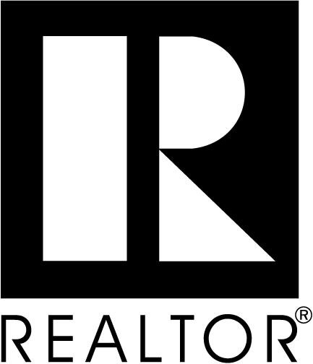
Exchange of Commitments


As your Agent, I commit to providing all of these services:

- Provide a complete explanation of the home buying process.
- Provide thorough knowledge of the current and emerging real estate market conditions
- Assist you in selecting the best home for you, for your money.
- Write your purchase agreement to correctly and clearly express your intentions and represent your interests.
- Submit your purchase agreement in a manner that will present you in the most favorable position.
- Review all offers in detail and provide negotiation representation of your interests.
- Provide assistance in obtaining the best possible financing of your next home.
- Coordinate the closing of your purchase with other Realtors, Lenders, Inspectors, Appraisers, Attorneys, Escrow officers, and Title insurance companies.
- Provide on-going personal communication to keep you informed on the step-by-step progress of the purchase of your home.
- Provide post-sale follow up to assure your total satisfaction.

As the Buyer, I commit to buying a home through _________________________
Real Estate Agent:
- Using said Agent if they find me what I want.
- Using said Agent if I find what I want.
- Using said Agent if another agent finds me want I want.

_______________________________ _______________________________
Real Estate Agent Date Buyer Date


Company Name
Agent Name
Phone Number
Email

